**Summer is Here!**

I

t is official Summer is here! Thursday, June 20, officially marked the beginning of the summer season. The days are longer, school is out, vacations are being planned, and what a great time to plan those outdoor picnics and barbeques. Aging should not stop you from enjoying these summer activities. Getting outdoors provides great health benefits that can improve your health and well-being. Spending time outdoors can help improve your mental health. Seniors who spend time outdoors may experience less depression and anxiety. Getting outside helps fight “mental fatigue.” One way to help get your mind back in gear is exsposing it to a restorative environment. The natural beauty of the outdoors can help boost your mental energy again. Getting outdoors can enhance relationships and diminish feelings of isolation. Whether through meeting new people or spending time with family and friends, getting outdoors promotes social interaction which increases one’s sense of purpose and accomplishments. So we would like to share with you some summer tips that can help you safely enjoy the great outdoors.

**Health & Safety Tips for Summer Outdoor Activities.**

1. **Hydrate, Hydrate, Hydrate** – If you are thirsty, you are already becoming dehydrated. As we age, our bodies naturally lose the ability to conserve fluid. Drink consistently throughout the day.
2. **Wear Proper Sun Protection** – Our immune systems become weaker over time. Use a sunscreen with **an SPF of 30 or more.** Apply generously every two hours. Look for water-resistant sunscreen.
3. **Dress Right** – Wear protective clothing when out in the heat. Consider wearing the following: Lightweight, long-sleeved shirts and log pants; A wide-brimmed hat; UV filtering sunglasses.
4. **Know the Signs of Heat Exhaustion and Heat Stroke** – Heat exhaustion and heat stroke are two serious medical conditions. Some of the most common signs are: Red or flushed skin; Rapid heartbeat; Tiredness; Headache; Confusion; Dizziness; Nausea.
5. **Know Your Medication Interactions** – Some medications may cause your body to be more sensitive to the sun. Make sure you and your loved ones know if your prescription medicine requires you to take extra precautions when in the sun.
6. **Prevent Trips and Falls** – Take extra precaution when on unfamiliar terrain. Outdoor rugs, pool decks, sandy shores, or uneven patio flooring can quickly become a safety hazard. Keep areas well-lit and clean. Wear comfortable, well-fitting, non-slip footwear.

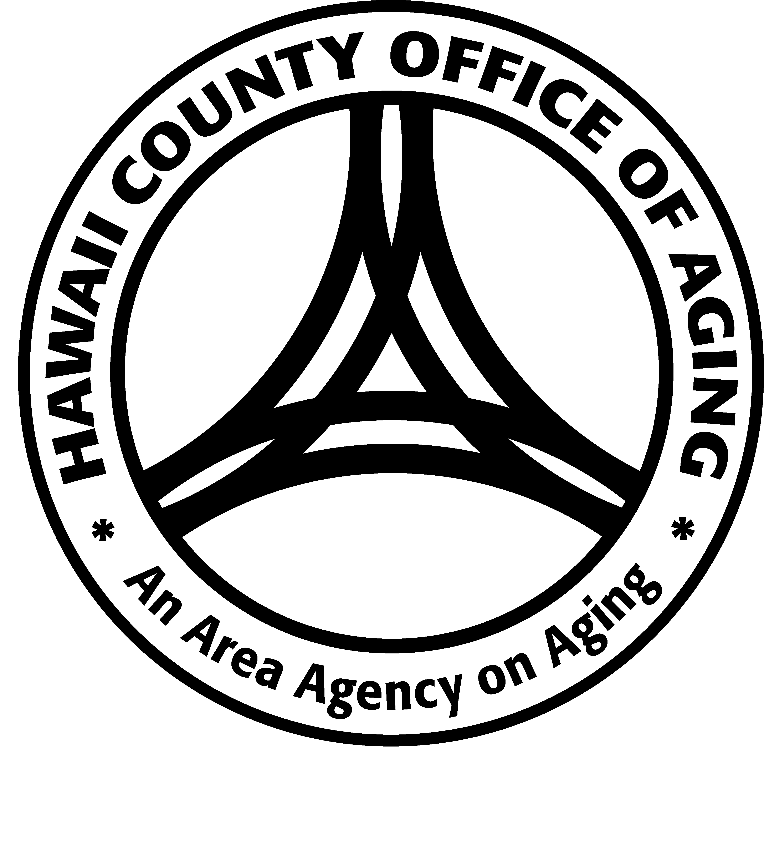There are many options available to getting out to enjoy this summer season. You do not have to take a challenging hike to reap the health benefits of being outdoors. No matter how you choose to do it, getting outdoors has many health benefits in store for you. As you explore the outdoors this summer, please be sure to pratice the above health and safety tips for Summer outdoor activities. Most of all, always stay in contact with your family and friends. For more information and tips please call the Aging and Disability Resource Center at (808) 961-8626.

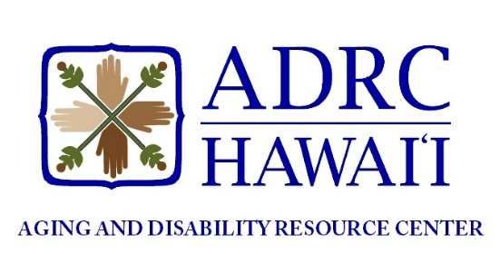**ADRC CORNER**

*Aloha! The Aging and Disability Resource Center (ADRC) is an access point for older individuals, caregivers and people with disabilities.*

The ADRC provides information, resource awareness, and assists with directing people to services and supports island-wide. Aging and Disability Service Specialists are available to answer questions and provide assistance.

***Please call us to schedule an appointment Monday through Friday from 8:30am-3:30pm (closed on holidays).***

***Hilo (808-961-8626)******Kailua-Kona (808-323-4392****)*

The Hawaii County Office of Aging and the Aging and Disability Resource Center would like to extend a heartfelt congratulations to the 2024 Outstanding Older Americans!

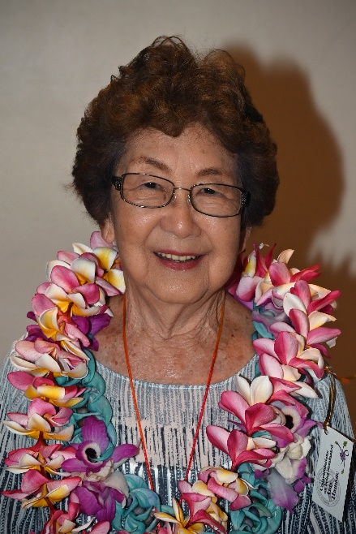**Outstanding 2024 Wahine Hawaiʻi County – Amy Hamane (85)**

**Tell me about where you grew up. What is a favorite childhood memory?**

Playing outside. We used play with these tiny dolls that could fit into matchstick boxes...We would climb guava trees that are no longer there now. I grew up right behind Hilo Intermediate School. I now moved back into the house that I grew up in. After I got married, I moved out of the house and we had our own home. But when my mom died, that’s when we moved back. And that [living in my childhood home] has been really nice.

**Do you feel there is something special about Hilo that connects you?**

It’s got to be the people… I worked for 30years at the American Lung Association and we were very dependent on volunteers to help us do our programs…to do fundraising, all the different things we did. We relied on volunteers because we had a very small staff and people were always willing to come out and help us. And so now that’s what I’m trying to do… volunteer and continue that…

**Do you think you’re like your parents or different?**

I think I’m like my parents. You know, my dad was the one who started what is now the Silver Bulletin. It was called The Grape Vine when he put it together and…when I think back now, I think that is so amazing because my dad did not graduate high school and he got his engineering degree from…a correspondence course, long-distance learning. But when he got older and became a senior, he got very interested and involved in all the senior activities that were offered in the Pomaikai Senior Program. My mother was too.

**What other ways did your elders influence you?**

Mostly by example. Because I don’t remember them giving lectures to direct us in any kind of way. So it must have been by example.

**Any advice for our Keiki, leaders, or community in general?**

Mostly, I’d like to give advice for the younger seniors. You know, those who have just retired. I’d like you to mention that I’m going on 86. I think the fact that I’ve been able to reach this age and still be active is because…I HAVE been active. Take advantage of what we have in the community. Kamana has got to be the BEST senior program in the state! We have so many choices and I’ve been taking classes for at least 10 years, if not more than that…and I still do. It makes a big difference.

My involvement in the AHCD program and the Senior Lecture Program….I think doing something that gives you responsibility, makes you get up every day and think “Ok what am I going to do?”. A purpose. And having to challenge yourself. I’ve taken gardening…cooking classes…and last years I strted taking ZenTangle classes and everyone asks me…What is THAT? I’m not creative…but I learned I can copy very well and I’ve really come to enjoy the class…but it was another challenge and…its important! Take the iPhone class! You learn so much.

**What is the secret to finding and maintaining fulfillment and peace in life?**

For me…it’s family. You know, I’ve always wanted my family to be strong and happy. We’ve always gotten together over meals, not every day but several times a week…always to have dinner TOGETHER. Not everyone eating alone, on their own with the phone out. I have 3 daughters and they have 5 boys. I have 5 grandsons and 1 granddaughter… she was the last. And now I have a great grandson and a great granddaughter so I think it’s nice…having family.

There’s one thing I want to mention…and that has to do with hearing. Why is it that we don’t mind wearing glasses or talking about cataracts, vision failing…but we don’t want to talk about hearing! And so many people resist getting hearing aids…and that’s sad. If I took out my hearing aids I wouldn’t be able to hear you. I REALLY have severe hearing loss…hearing aids are not perfect, but they are a big help to be able to function and be out in public and not be isolated because you can’t hear.

It’s something I talk about a lot because I think it’s important. Why do we think it’s embarrassing to lose your hearing? It’s a natural part of aging. It’s just like wearing glasses. Don’t withdraw because you cannot hear.



**Outstanding 2024 Kane Hawaiʻi County – Robert Terukina (79)**

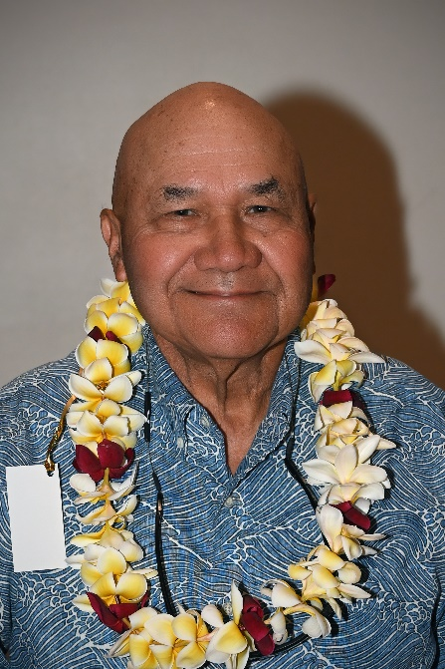This outstanding Male Honoree believes in being kind, loving, patient, and respectful. In retirement Robert continues to live out his philosophy of serving others with kindness and humbleness. Volunteering is in his blood. As a former teacher and counselor, he has a great passion to help young people grow and mature into responsible community members. Robert’s biggest goal in working with and teaching youth is to have them realize, “the highest goal in life is to give back.” This desire to serve leads him to volunteer his time weekly as a HAM radio operator. His involvement as a HAM Radio operator, and a member of the Community Emergency Response Team (CERT) is vital to helping keep communications open during emergencies. Robert believes, in any situation in life, communication is an important skillset. “Communication is one of the essential building blocks of the growth process to becoming a beneficial asset to your community,” said Robert.

Robert loves to farm. He and his wife actively grow a variety of fruit trees, taro, and several types of vegetables. His passion for others leads him to share any produce not sold at the Farmers Market with individuals within the community. Robert is a board member of the Waimea Hui Project. Sponsored by the State Agricultural Department, this organization develops greenhouses for community use. He was instrumental in helping to organize the Waimea Farmers Market and assisting in the process of getting a certified kitchen built for community use. Besides farming, Robert recognizes the importance of balancing his healthy aging activities with regular exercise. He enjoys tennis and actively participates in several clubs. He loves music and enjoys playing the ukulele and he and his wife faithfully every year volunteer to ring the bells at Christmas for the Salvation Army.

In all the things that Robert is actively involved in, whether it be at home or in the community. In all the community service projects he has volunteered for, or still participates in. Everything that Robert does is driven by the core values that he believes in and practices in his daily life. His life guiding motto is: “**K-L-P-R**, Be **K**ind, Be **L**oving, Be **P**atient, and most of all Be **R**espectful.”

# Floral Vine Border Designs - Design Talk

# Scammers use AI to enhance their family emergency schemes

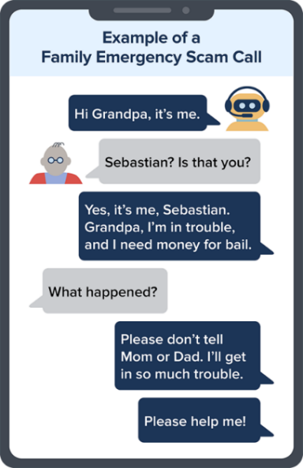http:www.consumer.ftc.gov/consumer-alerts/2023/03/scammers-use-ai-enhance-their-family-emergency-schemes By Alvaro Puig March 20, 2023

You get a call. There's a panicked voice on the line. It's your grandson. He says he's in deep trouble — he wrecked the car and landed in jail. But you can help by sending money. You take a deep breath and think. You've heard about grandparent scams. But darn, it sounds just like him. How could it be a scam? Voice cloning, that's how.

Artificial intelligence is no longer a far-fetched idea out of a sci-fi movie. We're living with it, here and now. A scammer could use AI to clone the voice of your loved one. All he needs is a short audio clip of your family member's voice — which he could get from content posted online — and a voice-cloning program. When the scammer calls you, he’ll sound just like your loved one.

So how can you tell if a [family member is in trouble](https://consumer.ftc.gov/articles/scammers-use-fake-emergencies-steal-your-money) or if it’s a scammer using a cloned voice? Don’t trust the voice. Call the person who supposedly contacted you and verify the story. Use a phone number you know is theirs. If you can’t reach your loved one, try to get in touch with them through another family member or their friends.

Scammers ask you to pay or send money in ways that make it hard to get your money back. If the caller says to [wire money](https://consumer.ftc.gov/articles/you-wire-money), send [cryptocurrency](http://www.consumer.ftc.gov/articles/what-know-about-cryptocurrency-and-scams), or [buy gift cards](https://consumer.ftc.gov/articles/gift-card-scams#what%20to%20do) and give them the card numbers and PINs, those could be signs of a scam. If you spot a scam, report it to the FTC at [ReportFraud.ftc.gov](https://reportfraud.ftc.gov/#/).

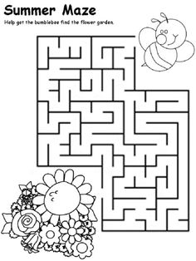

Hearing Loss and the Dementia Connection

*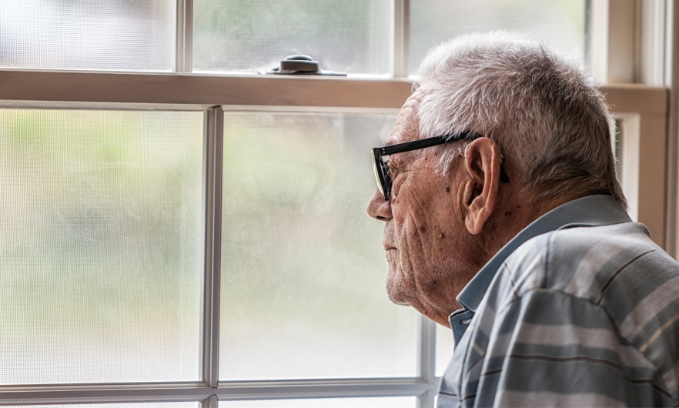ORIGINAL ARTICLE AT: www.publichealth.jhu.edu/2021/hearing-loss-and-the-dementia-connection*

Published November 12, 2021

Hearing loss doesn’t just mean an older adult needs to turn up the TV. It’s been linked to a range of health problems, including dementia. The latest aging research not only shows the two are connected, it’s also leading scientists to believe that hearing loss may actually be a cause of dementia.

This emerging area of research has huge implications, says [Frank Lin, MD, PhD](https://publichealth.jhu.edu/faculty/2634/frank-r-lin) , director of the[Cochlear Center for Hearing and Public Health](https://jhucochlearcenter.org/) at the Bloomberg School. Some 37.5 million Americans have trouble hearing, according to the [National Institute on Deafness and Other Communication Disorders](https://www.nidcd.nih.gov/health/statistics/quick-statistics-hearing).

A key question researchers have: *Could hearing aids reduce the risk of a person developing dementia*?

Lin explains the connection between the two conditions and where the science is headed.

**Hearing loss and the brain**

If you have hearing loss, you have a greater chance of developing dementia, according to a[2020 Lancet commission report](https://www.thelancet.com/article/S0140-6736(20)30367-6/fulltext) that lists hearing loss as one of the top risk factors for dementia.

**Brain strain and social isolation**

Hearing loss can make the brain work harder, forcing it to strain to hear and fill in the gaps. That comes at the expense of other thinking and memory systems. Another possibility: Hearing loss causes the aging brain to shrink more quickly. A third possibility is that hearing loss leads people to be less socially engaged, which is hugely important to remaining intellectually stimulated. If you can't hear very well, you may not go out as much, so the brain is less engaged and active.

**Quantifying hearing loss’s impact**

Hearing loss is estimated to account for[8% of dementia cases](https://www.thelancet.com/infographics/dementia-risk). This means that hearing loss may be responsible for 800,000 of the [nearly 10 million new cases](https://www.who.int/news-room/fact-sheets/detail/dementia) of dementia diagnosed each year.

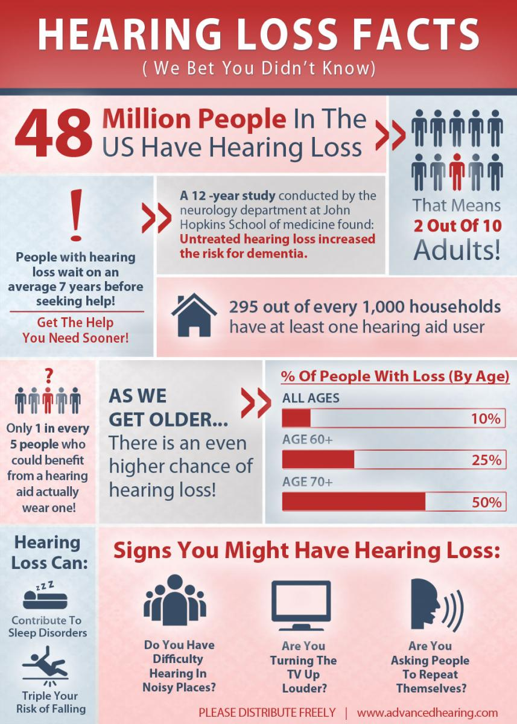**Reducing the risk of dementia**

Johns Hopkins is leading a large[National Institute on Aging study](https://clinicaltrials.gov/ct2/show/NCT03243422) to see if hearing aids can safeguard seniors’ mental processes. The [study](https://clinicaltrials.gov/ct2/show/NCT03243422) has multiple locations and has recruited nearly 1,000 people ages 70–84 with hearing loss. One group is provided hearing aids, while another group receives aging education. By early 2023, the study should provide definitive results on whether treating hearing loss will reduce the risk of cognitive decline. In essence, we’ll know whether the use of hearing aids can potentially reduce brain aging and the risk of dementia.

**Other effects on health**

Hearing loss has long-term effects on health. It’s believed to increase the risk for falls and depression. It also leads to higher health care costs: People with hearing loss have, over 10 years,[a 47% increased rate of hospitalization](https://www.thelancet.com/infographics/dementia-risk).

[**National Hearing Aid Project**](http://www.hearingaiddonations.org/)Provides hearing aids and hearing health services to low-income individuals.  
[http://www.hearingcharities.org](http://www.hearingcharities.org/)

**Hearing Health 4 U**  
Helping low income people break the barrier of the high cost of hearing aids – by providing quality new and used hearing aids at a very affordable price. Financial assistance available.  
http://www.hearinghealth4u.co

**Upcoming Events**

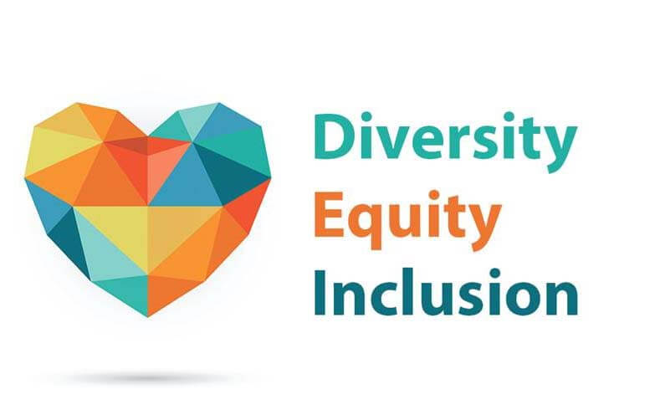

**July-** Disability Pride Month

**July 4-** Independence Day **(H)**

**August-** World Cancer Support Month

**August 16-** Statehood Day **(H)**

**September-** National Hispanic Heritage Month

Healthy Aging Month

Falls Prevention Month

**September 2-** Labor Day **(H)**

****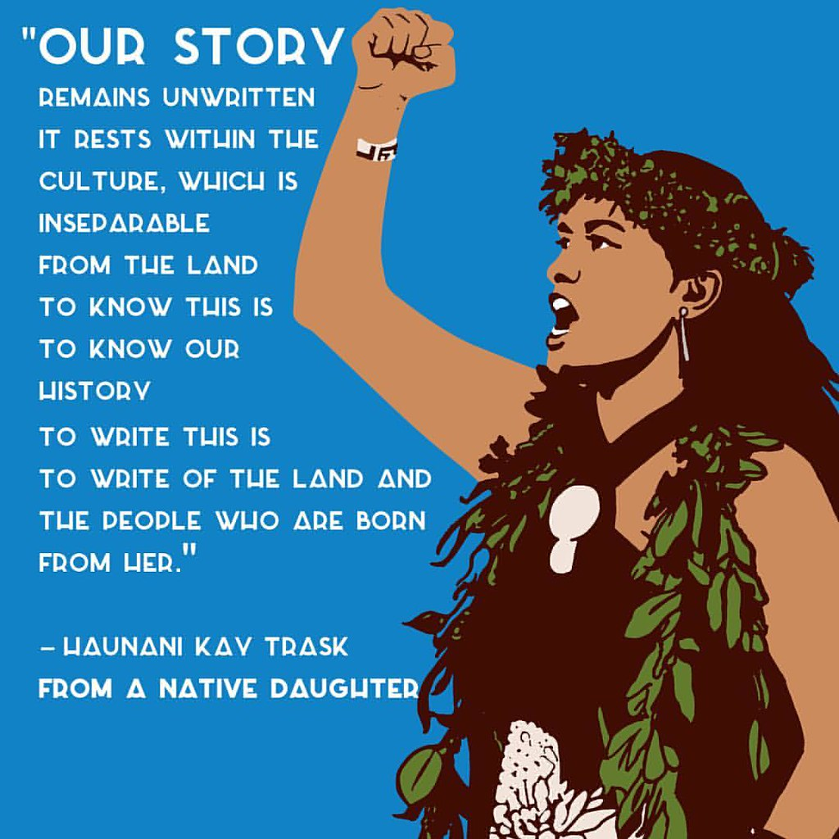**In observance of Hawaii Statehood Day, the Hawaii County Office of Aging and the Aging and Disability Resource Center will be closed on August 16, 2024.**

# Happy Disability Pride Month![Why and How to Celebrate Disability Pride Month](https://thearc.org/blog/why-and-how-to-celebrate-disability-pride-month/)

*Original article at: www.thearc.org/blog/why-and-how-to-celebrate-disability-pride-month/*

**May 1, 2024 by The Arc**

Disability Pride Month is celebrated every July and is an opportunity to honor the history, achievements, experiences, and struggles of the disability community. Why July? It marks the anniversary of the Americans with Disabilities Act (ADA), landmark legislation that broke down barriers to inclusion in society.

People with disabilities deserve to live full, self-determined lives, just like everyone else. Yet discrimination persists for the 1 in 4 U.S. adults living with a disability. That’s why we spotlight inspiring stories in July and beyond that show what’s possible with inclusion.

## The History of Disability Pride Month

Disability Pride Month happens every July to mark the ADA’s anniversary, which was passed on July 26, 1990. The first celebration was a Disability Pride Day that took place in Boston in 1990. Chicago hosted the first Disability Pride Parade in 2004. Now there are events nationwide empowering people with disabilities to take pride in who they are. Here’s more about [the history of Disability Pride Month](https://www.womansday.com/life/a43964487/disability-pride-flag/) and the story behind the flag.

## 2024 Theme: “We Want a Life Like Yours”

This theme comes from The Arc’s National Council of Self-Advocates. It reflects the disability community’s dreams for life experiences that they are diverse stories of people with disabilities thriving as students, employees, leaders, engaged members of their communities and families, and more given a chance. too often denied. All month, we’ll share

## Learn About the Disability Experience

* **Meet People With Disabilities:** The more we listen to people with disabilities and share their truths, the more we can drive positive change!
* **Learn About Disability Rights in the United States:**
  + The treatment of people with disabilities throughout our history is marked by segregation, discrimination, and attacks on their basic human rights. We also encourage you to watch and read media that has been created by and with people with disabilities.

Take Action

* **Reach Out to Your Elected Officials:** Educate your elected officials about policies that harm or strengthen the quality of life of people with disabilities. Make sure you bookmark [The Arc’s Action Center](https://p2a.co/lRPDZ5C?p2asource=blog) for timely alerts!
* **Donate to The Arc:** For nearly 75 years, The Arc has been at the forefront of positive change in disability rights, and we’re not slowing down! [Donate to join our grassroots movement](https://donate.thearc.org/give/169425/#!/donation/checkout?c_src=disability-pride-month-blog) that is creating policy, programs, and possibilities for people with disabilities.

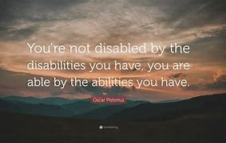

## Teach Your Kids to Acknowledge and Include Disabled People

Help foster inclusion for future generations of people with disabilities.

## Hire People with Disabilities

Right now, 85% of people with intellectual and developmental disabilities (IDD) are unemployed. Many of them want to work and have skills to contribute. Among those who are employed, people with IDD are working fewer than 13 hours a week on average and less than one-fifth of them are getting workplace benefits. But research shows that disability inclusion is a proven good business decision.

 **There are many other ways you can celebrate Disability Pride Month, and we hope this list gives you a good starting point. Thank you for doing your part to amplify the voices and experiences of people with disabilities!**

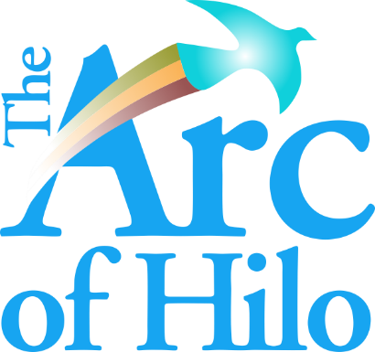The Arc of Hilo provides a range of community support services, including Adult Day Care, Personal Assistance, Supported Employment and Vocational Training, and support in navigating the social services system.

[(808) 935-8534](tel:8089358534" \t "_self)

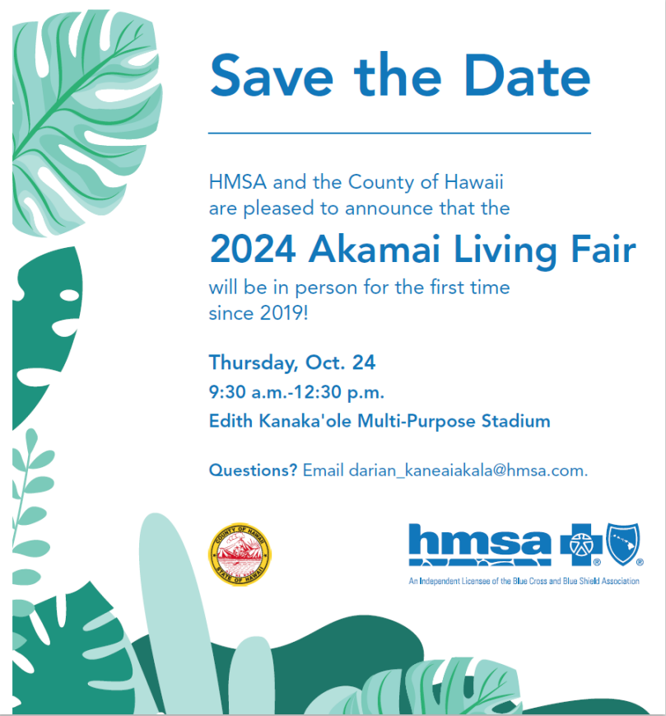

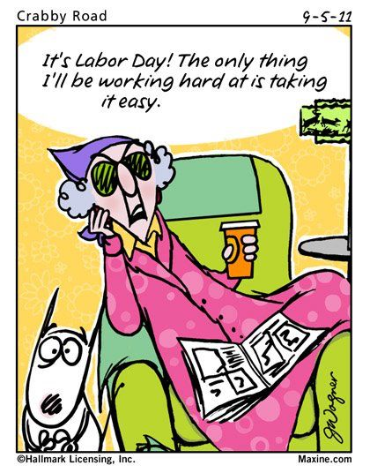

SMALL KINE FUNNY KINE

Why did the scarecrow win an award?

\*Because he was outstanding in his field.

What do lawyers wear to work?

\*Lawsuits.

What did the elevator say when it sneezed?

\*“I think I’m coming down with something.”

Did You miss

our Fall

Prevention

Training?



Scan the QR Code

with your phone

camera and click

on the link!

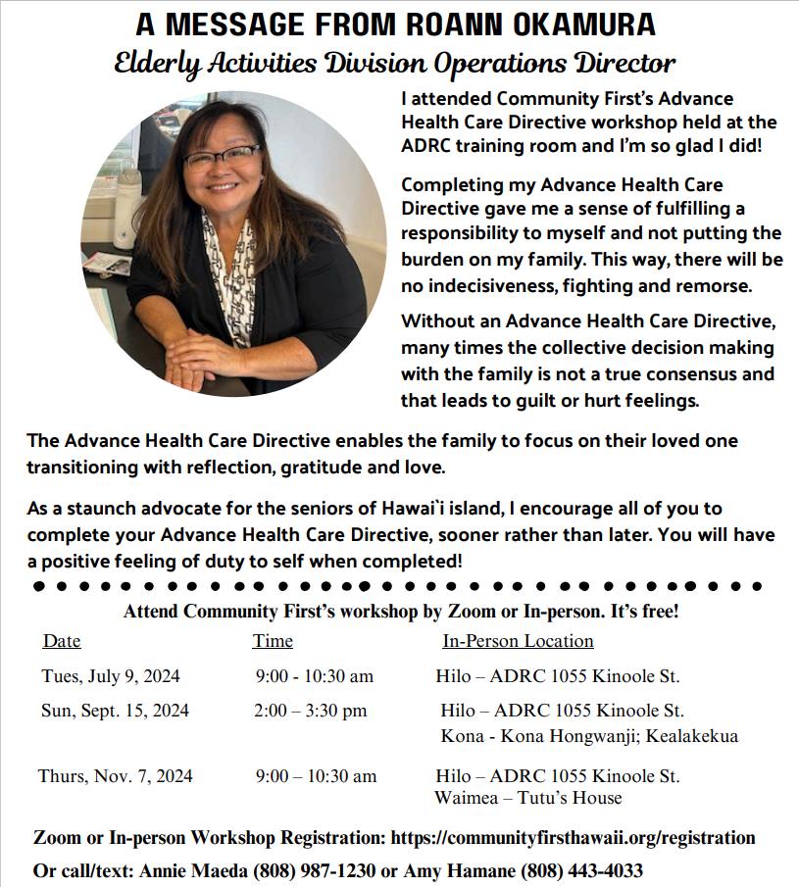

### 10 Minutes to let your mind wander - creative inspiration Journal Writing Prompts, Journal Pages ...Piece of summer berry frozen dessert on a white plate with lot of mixed berries behind. **Summer Berry Frozen Dessert**

This **Summer Berry Frozen Dessert** is an easy no bake cake recipe that makes for a refreshing summer treat. It’s a delicious, creamy cheesecake with a mix of fresh summer berries, graham cracker crust and crunchy crumb topping. A festive, red, white and blue dessert, perfect for a 4th of July celebration.

### **Ingredients**

#### **Graham Cracker Crust and Crumb Topping:**

* 3 cups graham cracker crumbs
* 6 Tablespoons light brown sugar
* ¾ cup unsalted butter-melted
* Berry Cheesecake Filling:
* 16 oz. cream cheese-softened (use brick style cream cheese)
* 1 (14 oz.) can sweetened condensed milk
* 1 teaspoon vanilla extract
* 4 Tablespoons fresh lemon juice
* 2 ½–3  cup fresh berries ( I used about 1 ¼  cup blueberries, 3/4 cup raspberries and 1/3 cup diced strawberries)

### **Instructions**

1. In a bowl stir together graham cracker crumbs and brown sugar. Then add melted butter and stir well until evenly moistened.
2. Grease bottom of 9×9 inch dish with non-stick spray.  Press almost 2/3 of the mixture in the bottom of the dish and chill in the freezer while making the filling.
3. To make the filling using an electric mixer set at medium-high speed, beat the cream cheese in a large bowl until smooth. Beat in the condensed milk a little at a time, scraping the sides of the bowl, as necessary. Beat in the lemon juice and vanilla. Finally, fold in berries.
4. Spread the filling over chilled crust and sprinkle with remaining crumbs.
5. Freeze at least 5-6 hours or overnight.

Hawai’i County Office of Aging

1055 Kino’ole St.

Suite 101

Hilo, HI 96720C:\Users\kelli\Desktop\Silver Bulletin 2020 Doucments\COH Logo.pngC:\Users\kelli\Desktop\Silver Bulletin 2020 Doucments\HCOA Logo.png

Thank you to our Senior Training & Employment Worker:

Stuart Taketa

|  |  |
| --- | --- |
| **HILO STAFF** | |
| Luana Ancheta-Kauwe | Information & Assistance Clerk |
| Meredith Catalini | Aging & Disability Services Manager |
| Lori Enomoto | Information & Assistance Clerk |
| Charmaine Felipe | Administrative Services Assistant I |
| Clayton Honma | Aging Program Planner III |
| Keola Kenoi | Aging Program Planner II |
| Kimberlee Sato | Aging & Disability Services Specialist I |
| Leilani DLG Westergard | Aging & Disability Services Specialist I |
| Jolean Yamada | Aging & Disability Services Manager |
| Bryan Yoshioka | Data Processing Clerk I |
| **KONA STAFF** | |
| Alice Bratton | Aging & Disability Services Specialist I |
| Debbie Wills | Aging Program Planner II |
|  | |
|
|
|

|  |  |  |  |  |  |  |  |  |  |  |  |  |  |  |  |  |  |  |  |  |  |  |  |  |  |  |  |  |  |  |  |  |  |  |  |  |  |  |  |  |  |  |  |  |  |  |  |  |  |  |  |  |
| --- | --- | --- | --- | --- | --- | --- | --- | --- | --- | --- | --- | --- | --- | --- | --- | --- | --- | --- | --- | --- | --- | --- | --- | --- | --- | --- | --- | --- | --- | --- | --- | --- | --- | --- | --- | --- | --- | --- | --- | --- | --- | --- | --- | --- | --- | --- | --- | --- | --- | --- | --- | --- |
| |  | | --- | | **HILO OFFICE** | | 1055 Kino'ole Street |  | | Suite 101 |  | | Hilo, HI 96720 |  | | (808) 961-8600 |  | | Aging & Disability Services  (808) 961-8626 |  | | |  |  | | --- | --- | | **KONA OFFICE** |  | | 75-5044 Ane Keohokalole HWY | | Building B |  | | | Kailua-Kona, HI 96740 |  | | | (808) 323-4390 |  | | | Aging & Disability Services  (808) 323-4392 |  | | |  |  | | |  | | |  |  | | |  | |  | |  |  | |  |  | |  |  | |  |  | |  |  | |  |  | | (808) 961-8626 | | |  |  | | |
|  |  |
|  |  |
|  |  |
|  |  |
|  |  |
|  |  |
|  |  |
|  |  |
|  |  |
|  |  |
|  | |
|  |  |
|  |  |
|  |  |
|  |  |
|  |  |
|  | |
|
|
|

**HAWAI’I COUNTY OFFICE OF AGING**

**Executive on Aging William Farr III**

|  |
| --- |
| ***HCOA programs are funded by the County of Hawai’i, the State of Hawai’i through the State Executive Office on Aging and through Older Americans Act Title III funds.*** |
|